Introduction
MyAgencyPro is a streamlined Python application that automates your entire invoice workflow; from processing emailed attachments and generating RFPs to merging documents, drafting follow-up emails, syncing payment data, and running audits—all from one place.
Here are seven easy-to-use modules we will be using to automate the FH Agency Intake Process.
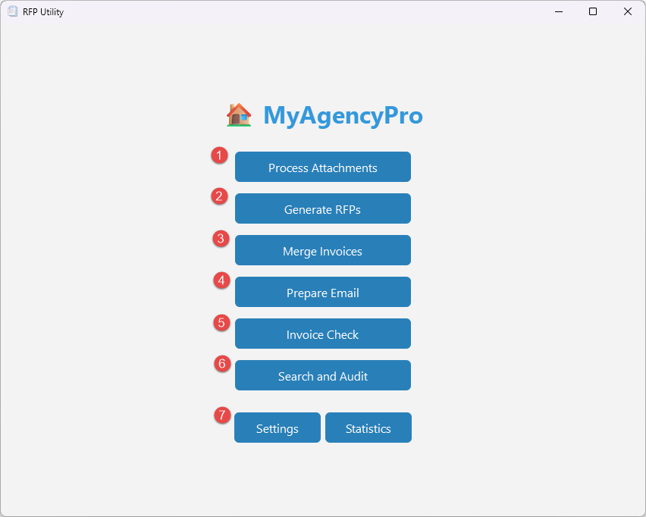
- Process Attachments
Bulk-extract supporting files from email exports.
- Generate RFPs
Autofill a standardized RFP PDF form with invoice data.
- Merge Invoices
Batch-merge invoice PDFs with their corresponding RFP documents.
- Prepare Email
Build Outlook draft messages to send statements and merged files.
- Invoice Check
Reconcile payment data against the master Excel tracker and update statuses.
- Search & Audit
Look up invoice details or create quarterly audit reports.
- Settings & Statistics
Configure your default file paths and view high-level usage metrics.

Launching the App
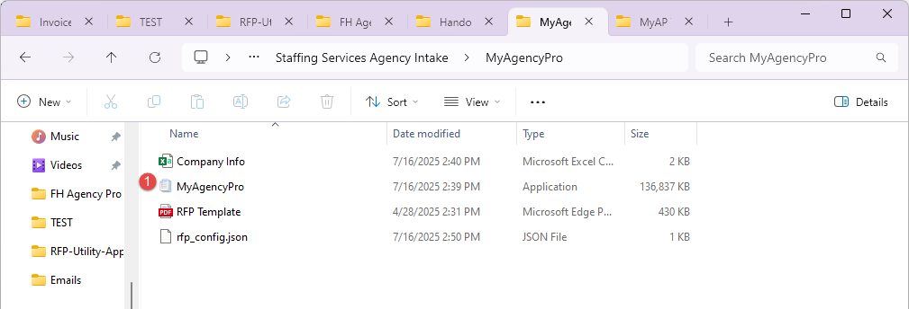
- Locate the EXE
  - Open File Explorer and navigate to
M Drive -> Staffing Services Agency Intake -> MyAgencyPro.
  - (Pro Tip: Create a shortcut on your desktop for quick access to the app.)
Video Tutorial
    - Go to Desktop
    - Right click -> New -> Shortcut
    - Paste this into the box: "M:\Staffing Services Agency Intake\MyAgencyPro\MyAgencyPro.exe"
    - Hit Enter twice
- Start
  - Double-click MyAgencyPro.exe (or use the shortcut from your desktop).
  - It may take a few minutes to load. Do keep an eye out for any window that opens up.

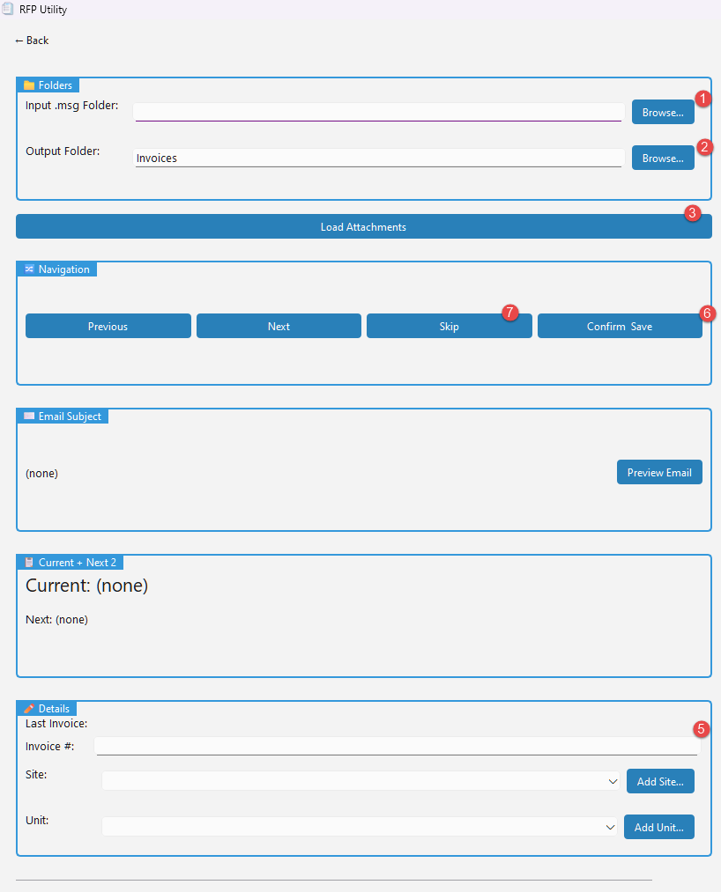
Process Attachments
Streamline incoming email attachments into your invoice tracker. Confirm key details (Site, Unit, Amount) as you go, ensuring every invoice is structured and ready for the next step.
- Input Folder: Browse to the folder containing your downloaded email (.msg) files.
- Output Folder: Confirm where attachments will be saved (do not change unless necessary).
- Click Load Attachments.
- Preview: A list of extracted files appears on the right.
- For each file, enter:
  - Invoice Number
  - Site
  - Unit
- Click Save to organize files under the Output Folder hierarchy.
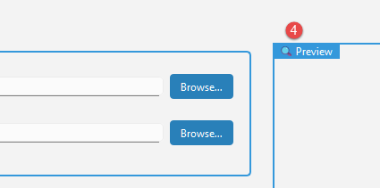

Generate RFPs
Automatically populate and produce RFP documents using the Company Info, invoice details from the tracker, and a standardized RFP template; no manual copying required.
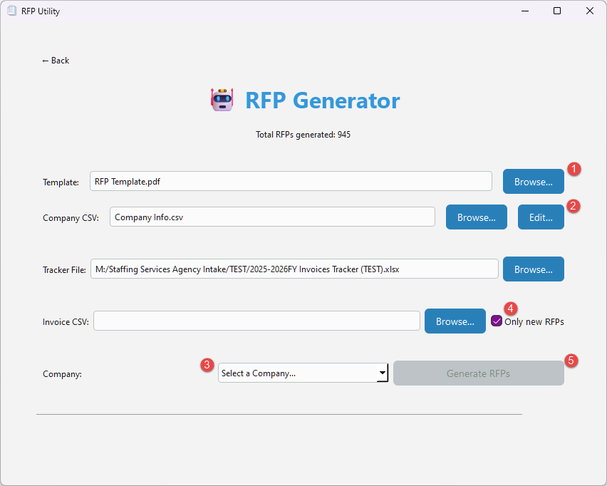
- Template PDF
  - Defaults to RFP Template.pdf
(do not change unless necessary).
- Company CSV
  - Defaults to Company Info.csv
(do not change unless necessary).
  - Click Edit to add, remove, or update companies from the existing list.
- Select a Company from the dropdown you want to generate RFPs for.
- (Optional) Check Only new RFPs checkbox to generate only for invoices not yet processed. Uncheck to generate all the invoices under the selected company
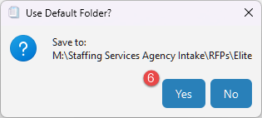
- Click Generate RFPs (enabled when all required inputs are valid).
- Choose an Output Folder when prompted.
  - The app creates a folder under the [Company Name] you selected.
(always use default folder unless necessary).

Merge Invoices
Combine each invoice PDF with its matching RFP into a single, organized file sorted by Site and Unit. Successfully merged items are archived; any mismatches are flagged for review.
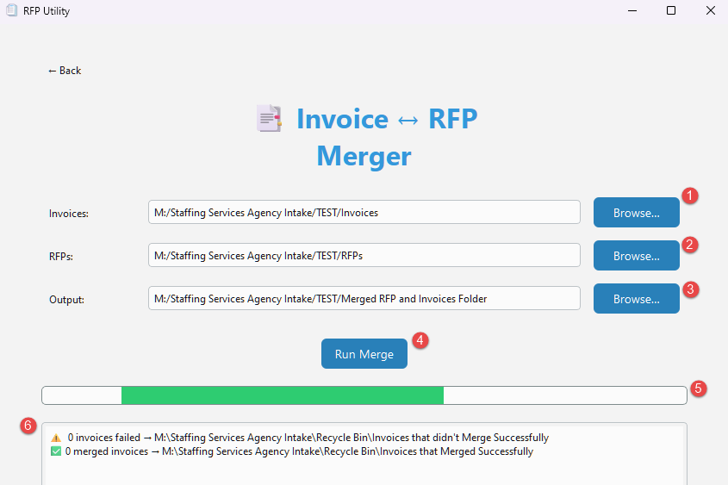
- Invoices Folder: Select the root directory containing your invoice PDFs.
- RFPs Folder: Select the directory holding your filled-in RFP templates.
- Output Folder: Choose where merged files will be saved.
- Click Run Merge.
- As the progress bar updates, the app will:
  - Scan each invoice PDF for invoice numbers.
  - Match to the corresponding RFP PDF.
  - Merge them into a single document.
  - Save it under your Output Folder, mirroring the input structure.
- View the Log Pane for success messages or any failed merges (listed in an Excel file).

Prepare Email
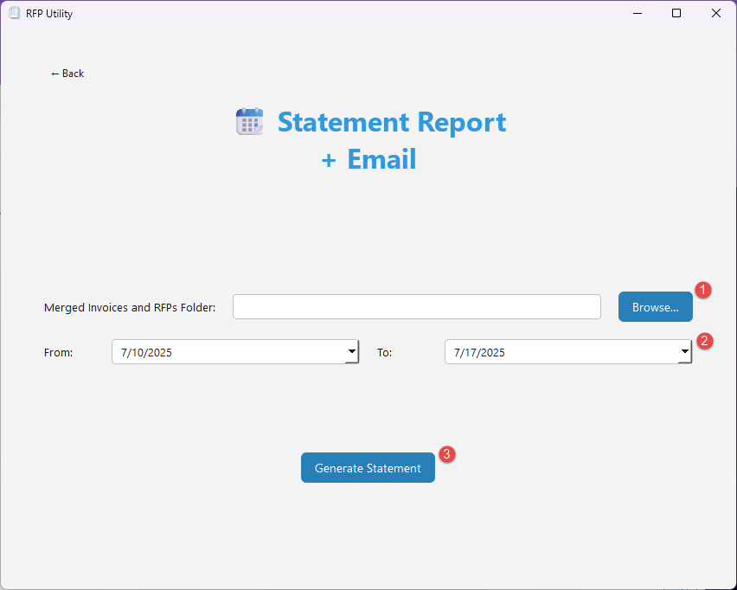
Draft batch emails (one per unit) with a templated message to managers/supervisors (based on cost center) with the invoices and the statement report attached.
- Merged Invoices Folder: Browse to where your merged PDFs reside.
- Date Range: Select the period this statement covers.
- Click Generate Statement.
- Select Output Location
- Outlook will open one or more draft emails:
  - To: Hospital manager(s)
  - Attachments: The merged invoices and statement report
  - Body: A pre-written message you can customize
- Review and Send from Outlook.

Invoice Check
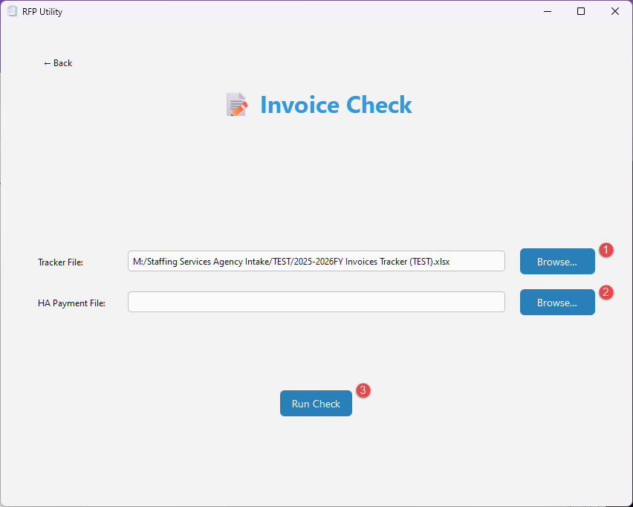
Keep your tracker in sync with Accounts Payable data. Upload the latest HA Payment file to automatically update statuses and remittance details, giving you a real-time invoice overview.
- Tracker File: Browse to your central Excel invoice tracker.
- Payment File: Browse to the payment export (Excel).
- Click Run Check.
  - The app recalculates paid vs. due, updates invoice status, and stamps remittance IDs.
  - It automatically generates a Pending Invoices report for any items overdue by more than 30 days.
- The updated tracker is saved, and any pending report opens automatically.

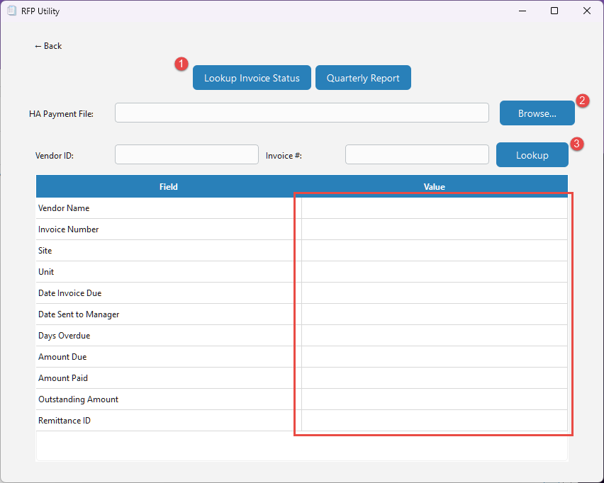
Search & Audit
Two powerful tabs:
- Invoice Lookup – Instantly find an invoice’s status by Vendor ID, Invoice Number, and HA Payment data.
- Quarterly Report – Bulk-audit hundreds of invoices at once, surfacing trends and discrepancies in one consolidated view.
- Choose between two tabs:
  - Lookup Invoice Status
  - Quarterly Report
- Upload the updated HA Payment file, (this can be used for both the tabs and will only need to be uploaded once).
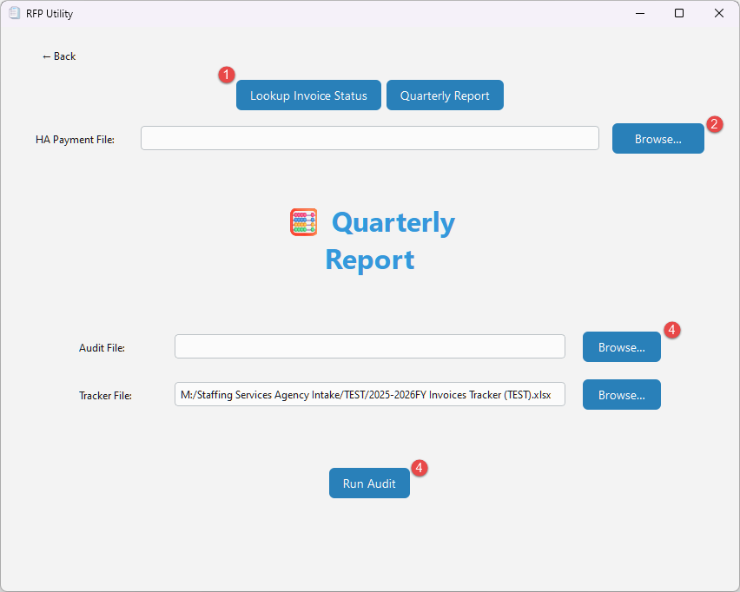
- Lookup Invoice Status
  - Enter a Vendor ID and Invoice Number, then click Lookup.
  - View the status and payment details.
- Quarterly Report
  - Upload an Audit File (Excel File with “VendorID” & “Invoice Number”).
  - Click Run to generate the consolidated quarterly report.

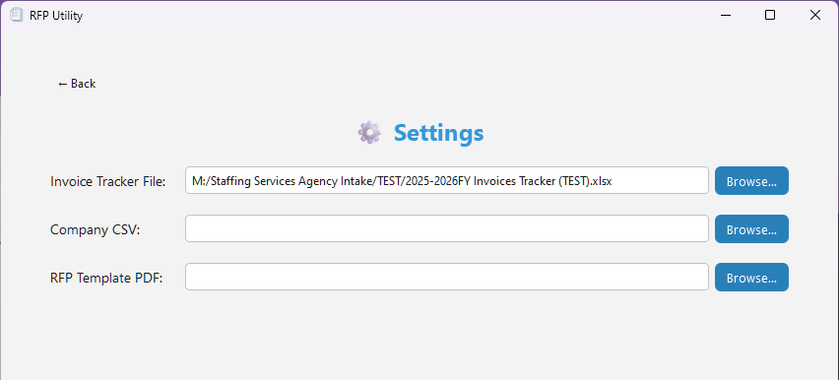
Settings & Statistics
Configure your default file paths and credentials in Settings, then monitor high-level metrics and trends in Statistics for deeper process insights.
Settings
- Click Settings.
- Default Paths
  - Set your preferred folders for templates, CSVs, and output locations.
Statistics
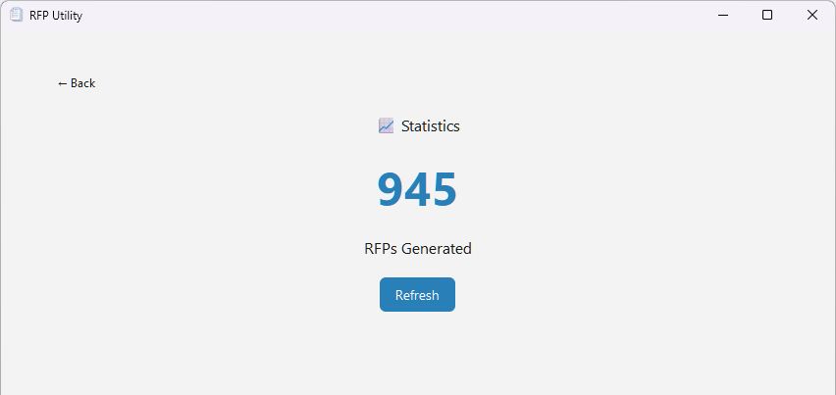
- Click Statistics.
- View high-level data, such as:
  - Total RFPs generated

HA Payment
To download the updated HA Payment File, go to this website: HA Payment - Power BI Report Server
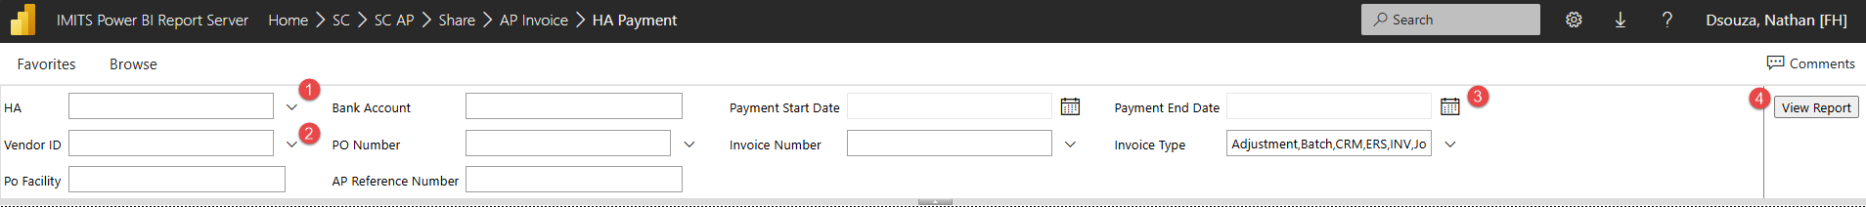
- Select the following:
  - Health Authority: FHA
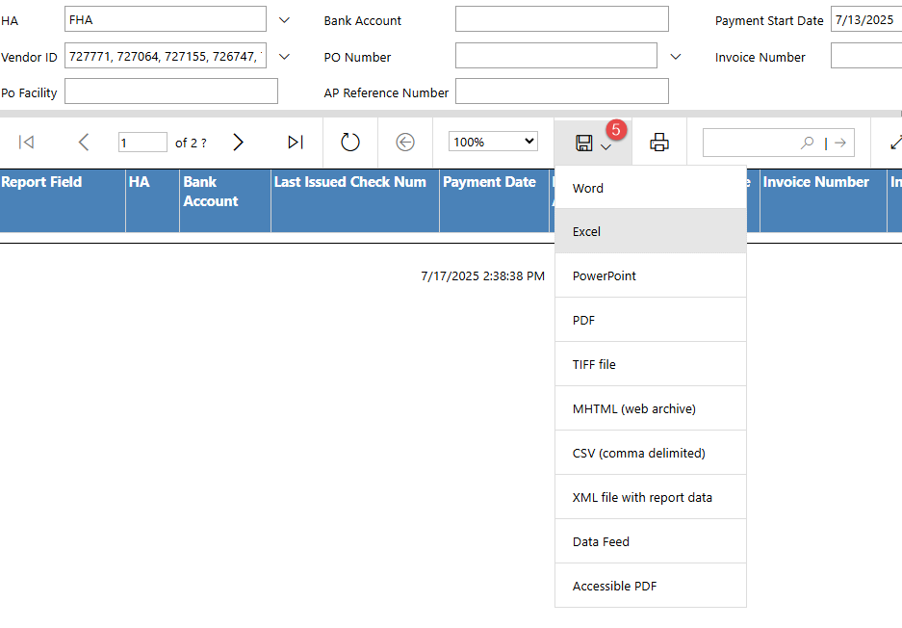
  - Vendor ID list: 727771, 727064, 727155, 726747, 727012, 726977, 726964, 727713, 726836, 726658, 716335, 713131, 726597, 728639
  - Date Range: April 1, 2022 – Todays Date
- Once done, click View Report (4)
- Hit the Save icon and save as Excel File (5)

Tips & Troubleshooting
- Invalid Path Warnings: Re-browse to correct any missing file or folder.
- No RFP Match: Means no template filename matched an invoice number—verify the invoice in your folders.
- Pending Report: Opens only if invoices are overdue by more than 30 days.
- Mirrored Output: Your Output Folder preserves the same subfolder structure as your input.
- Session Persistence: The app remembers your last-used settings for the next launch.

End of Guide

